Informatics Institute of Technology

In Collaboration With

University of Westminster, UK



*University of Westminster, Coat of Arms*

GATOT

Design

Mr. Nazhim Kalam

w1761265 / 2019281

Supervised by

Mr. Torin Wirasingha

September 2022

This Project Proposal is submitted in partial fulfilment of the requirements for

the BSc (Hons) Computer Science degree at

the University of Westminster.

Table of Contents

List of Figures ii

List of Tables ii

1. CHAPTER OVERVIEW 1

2. DESIGN GOAL 1

3. HIGH-LEVEL DESIGN 1

4. SYSTEM DESIGN 1

4.1 Choice of the Design Paradigm. 1

4.2 Data Flow Diagram 1

4.3 Algorithm Design 1

4.4 UI Design 1

5. CHAPTER SUMMARY 2

REFERENCES I

# List of Figures

Figure 12.1 - Prototype Feature Diagram (Self-composed) 13

Figure 13.1 - Gantt Chart 16

Figure 13.2 - Model development flow (Self-composed) 21

# List of Tables

Table 5.1 - Related work in abstractive text summarization 3

Table 11.1 - Research Objectives 9

Table 13.1 - Research Methodology 13

Table 13.2 - Deliverables and Dates 17

Table 13.3 - Risk Mitigation Plan 19

**Acronyms**

|  |  |
| --- | --- |
| AI | Artificial Intelligence. |
| DL | Deep Learning |
| GUI | Graphical User Interface |
| ML | Machine Learning |
| NLP | Natural Language Processing |
| ROUGE | Recall-Oriented Understudy for Gisting Evaluation. |
| BLEU | BiLingual Evaluation Understudy. |
| T5 | Text to Transfer Transformer. |
| BART | Bidirectional Auto-Regressive Transformers. |
| BERT | Bidirectional Encoder Representations from Transformers. |
| PEGASUS | Pre-training with Extracted Gap-sentences for Abstractive Summarization Sequence-to-sequence |
| ILP | Inductive logic programming. |
| LSTM | Long Short-Term Memory. |
| RNN | Recurrent Neural Network. |
| CNN  SEQ2SEQ | Convolutional Neural Network.  Sequence to Sequence |
| RoBERTa | Robustly Optimized BERT Pre-training Approach |
| GPT-3  REST  GPU | Third Generation Generative Pre-Trained Transformer  Representational State Transfer  Graphical Processing Unit |

# Chapter Overview

The design choices taken to create a suitable architecture for implementation, depending on the requirements received, are discussed in this chapter. To explain how the design goals are intended to be accomplished while outlining the justification for selected design decisions, high-level design, low-level design, design diagrams, and UI wireframes have been utilized.

# Design Goals

Table 6.1 – Design Goals of the proposed system

|  |  |
| --- | --- |
| **Design Goal** | **Description** |
| Performance | To find the new set of hyperparameters with the new data, model retraining requires a significant amount of time. As a result, the newly created dataset (with unseen data) should be accurately made, and it is best if it takes the least amount of time to query the data from various businesses within the same domain to create the dataset. Moreover, other core functionalities should be designed effectively to increase overall performance. |
| Correctness | The correctness & quality of the output should be of the highest possible level utilizing the optimized transformer architecture. Since several approaches are considered in order to get the optimized solution the expected output should of the best possible form. |
| Usability | The system's usability must be straightforward for users of all levels of knowledge because its primary function is to summarize review text for any domain, including movies and general users. |
| Scalability | In a production environment, the system may need to accommodate a large number of concurrent user requests. This should be manageable by the backend. The system should be easily expandable to accommodate new data. |
| Adaptability | Adopting new features or components need to be a simple procedure. The system shouldn't be broken if a component is added or removed, and it shouldn't be affected overall. |

# High-level Design

## **3.1 Tiered Architecture**

The image below depicts the architecture of the system. Three tiers of architecture separate the data, logic, and presentation levels. The system's generalization and domain specific adaptive hyperparameter tuning and data preprocessing represent the research contribution.

Figure 3.1: Three-Tiered Architecture (*self-composed*)

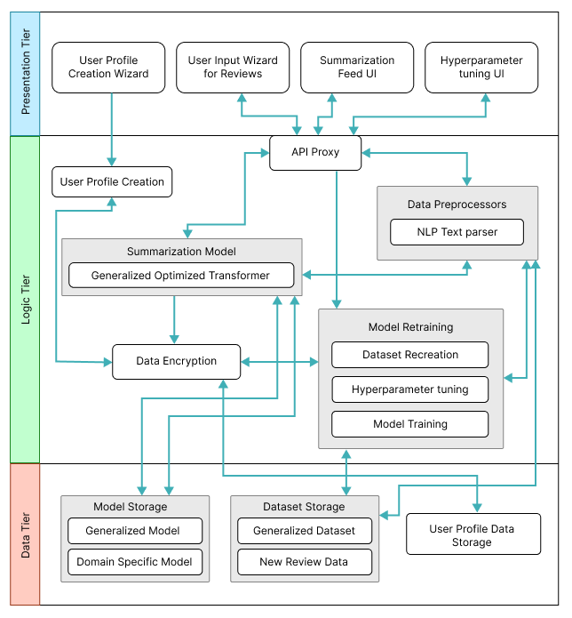

A microservice architecture is followed during the implementation of the project using several backend services, the design representation given above is just to give an idea of how all the components are expected to work together. To enable system scalability while assuring that failure areas may be quickly identified and handled individually, a microservices design is used.

The final prototype is expected to be run in a single machine even though the designed system is proposed to be run in a distributed server system. A thorough explanation of each module seen on the architectural diagram above is provided below.

**Data Tier**

1. Model Storage - The text summarization models which will be used for both generalized text summarization and domain specific text summarization will be stored here.
2. Generalized Model – The model which will be used by general users to generated review summarized, this model will be hyperparameter tuned for genialized purpose.
3. Domain Specific Model – The model will be used by domain specific users for review summarization, this model will be replaced whenever the model retraining is triggered from the domain user.
4. Dataset Storage – The data which is required for model training will be available.
5. Generalized Dataset – The data which is used for creating the generalized model will be stored for retraining when it comes to domain specific model retraining.
6. New Review Data – The data stored here are from the domain users when they use the application, the data will be storage and used for retraining along with the generalized dataset.
7. User Profile Data Storage – The metadata data related to the domain specific user when creating the user profile will be stored, for updating and profile deletion.

**Logic Tier**

1. User Profile Creation – Allowing to create unique user profiles for each domain user, main purpose comes when working with model retraining to figure out the data to be used.
2. API Proxy – Interface which allows the frontend to communicate with the backend services via HTTP calls/ request.
3. Data Preprocessors – The text data that will be used as input for the text summarizer must be cleaned using the preprocessing code.
4. NLP Text parser – Responsible for cleaning the input text review when received from the API endpoint.
5. Summarization Model – The model which will be responsible in generating the summary from the input review.
6. Generalized Optimized Transformer – This is the summarization model which will be used, an adaptive model depending on the domain and type of user interacting with the model.
7. Data Encryption – Data encryption is in charge of data protection/safety, keeping domain data extremely secure and leaving it useless even if it is stolen.
8. Model Retraining – Responsible for retraining the model with new data and finding new set of hyperparameters.
9. Dataset Recreation – Responsible for recreating the dataset with new data which has been given as input from the domain users
10. Hyperparameter tuning – Responsible for finding the new best set of hyperparameters using the new data.
11. Model Training – Responsible for training the new model with the new set of hyperparameters found.

**Presentation Tier (Client Tier)**

1. User Profile Creation Wizard – The UI that presents the user to create a new profile if they are planning to use the software for their domain business, or a general user to skip the sign up if only a generalized summary is required.
2. User Input Wizard for Reviews – The UI that will request the user to input the review which needs to be summarized.
3. Summarization Feed UI – The UI that displayed the summarized text for the input review.
4. Hyperparameter tuning UI – The UI that triggers model retraining when the domain user performs an action on it.

# System Design

## **Choice of the Design Paradigm.**

The main reason behind the author going ahead with **SSADM (Structured Systems Analysis and Design Method)** over **OOAD (Object-Oriented Analysis and Design)** to build the protype was due to the ease of ability to extend the system features when it comes to future developments of the system. Given below are the other factors as to why the choice of SSADM was considered:

* Object Oriented approaches will not make a greater benefit since the main core project research lies towards Data Science.
* Ability to demonstrate the MVP (Minimum Viable Product) prototype implementation for the research application is more convenient.
* More time efficient when concerned with the time constraint of having to complete the documentation research along with the project implementation.

## **Data Flow Diagram**

In order to show the relationships between components and provide a clearer understanding of how data flows across the whole system, the context diagram's components have been extensively broken down in the diagram below, which was detailed in the SRS previously.

Figure 4.1: Data Flow Diagram – Level 1 (*self-composed*)

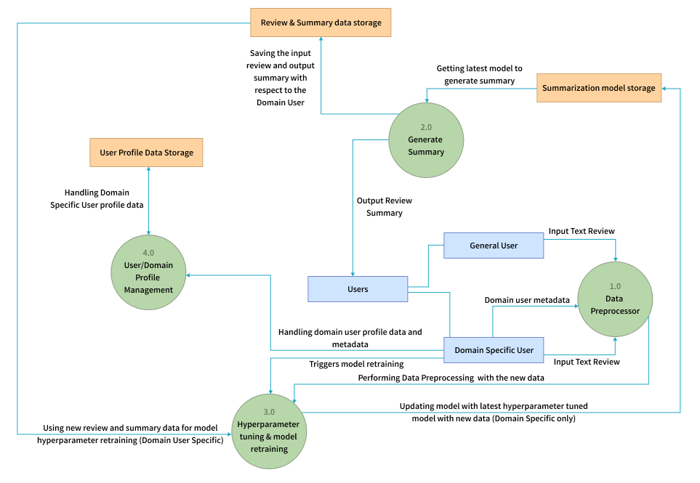

A more thorough explanation of the parts of the Level 1 Data Flow Diagram's components is given in the Level 2 Data Flow Diagram that is shown below.

Figure 4.2: Data Flow Diagram – Level 2 (*self-composed*)

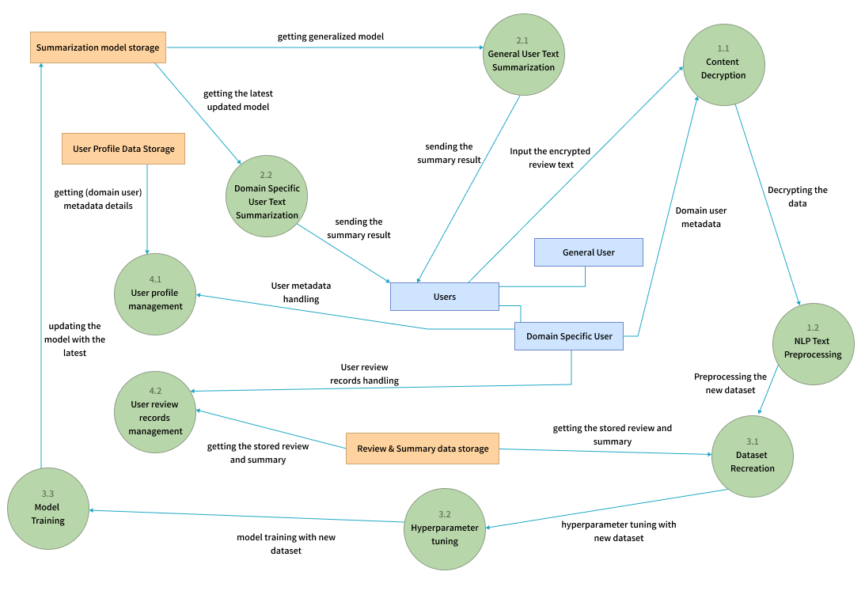

## **Algorithm Design**

# pending work

## **UI Design**

Given the specifications acquired from the target audience, the author chose a web application for the simulation of the proof-of-concept application. A responsive web application enables users to experience the program using any device. A wireframe design was created to depict the key user interface aspects in the system.

## **4.5 System Process Flow Chart**

# Chapter Summary

# References